User Guide

for

NASA Maestro Format Test Tool

**Version 2.0**

**Prepared by:**

**NASA TEAM 1**

**University of Maryland Global Campus**

**25 April 2020**

Table of Contents

**1** **Introduction** 4

**2** **Overview** 5

**3** **Conventions** 6

**4** **Acronyms** 7

**5** **Getting Started** 8

**5.1** **Create a New Project** 8

**5.2** **Upload a DOCX file** 9

**5.3** **Convert DOCX file to PDF file** 10

**5.4** **Convert PDF document to PNG file** 11

**5.5** **Compare Images** 12

**6** **User Access Considerations** 13

**7** **Accessing the System** 14

**8** **Error Messages** 15

**9** **Special Considerations** 17

**10** **Support** 18

**11** **Supporting Information** 19

**Revision History**

|  |  |  |
| --- | --- | --- |
| Version Number | Date | Description of Change |
| 1.0 | 04/22/2020 | Initial draft |
| 2.0 | 04/26/2020 | Update format and documentation |

# **Introduction**

This User Manual provides the information necessary for users of docker procedures to effectively use the NASA Maestro Format Test Tool (MFTT).

Our customers at the National Aeronautics and Space Administration (NASA) are requesting the development of a Maestro Format Test Tool (MFTT) system that could be utilized for NASA’s Extra-Vehicular Activity/Intra-Vehicular Activity (EVA/IVA). The display would be shown through the software created. The astronaut procedure steps will be shown on this display. The user will control this software with the basic steps of uploading, comparing, and selecting certain documents. The user of the software will be able to select the generated name and option of the document.

The intended audience for this document is astronauts and ground control personnel who oversee EVA procedures.

# **Overview**

Currently, the employees at NASA create spacewalk procedures known as EVAs. Typically, the steps that would include two astronauts that are located outside of two stations known as EV1 and EV2.

There are situations in which EV1 is focused on a task where all the steps can be done independently of EV2’s actions. There are other times when their steps are heavily intertwined. The same goes for robotics operators and Mission Control steps. The customers at NASA need to programmatically parse procedures, map each step to its respective actor, and display this on a hands-free screen (i.e. Maestro Format Test Tool).

The Maestro Format Test Tool (FTT) is used through a web browser's basic resolution. The astronaut takes steps that will be shown on this display of the browser. This Maestro FTT will also be programmed so that it can interact with comparing images.

The design for the Maestro FTT software is a standard web application consisting of a forward-facing web tier and a backend application tier. The web layer will serve as the user interface, serving the JavaScript, HTML, and necessary to render the UI. The application tier will consist of a node/express server responsible for handling HTTPS requests from the client. This layer will serve the data to the web tier.

# **Conventions**

This document provides screenshots using mock data and corresponding text to describe how to use the NASA Maestro Test Tool.

The term ‘user’ is used throughout this document to refer to a person who is interacting with NASA Maestro Test Tool.

# **Acronyms**

**FTT** – Format Test Tool

**EVA** – Extra-Vehicular Activity

# **Getting Started**

## **Create a New Project**

After accessing Maestro FTT software, the Procedure Select Create a New Project.

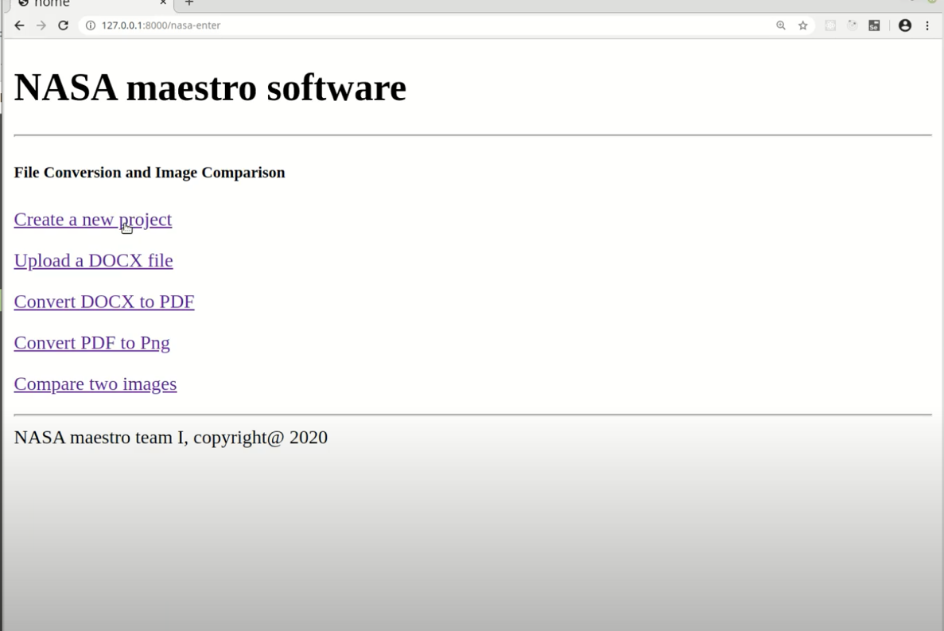

*Figure 1 – Create a New Project*

The user will then select the desired documents once they have clicked “Create a New Project”. For example: “Selecting the name of the project and then the document for the project”. After the procedure is selected.

## **Upload a DOCX file**

The user may now select the desired document for example: “File must be a DOCX file”. The Maestro FTT will then display the selected procedure for that page.

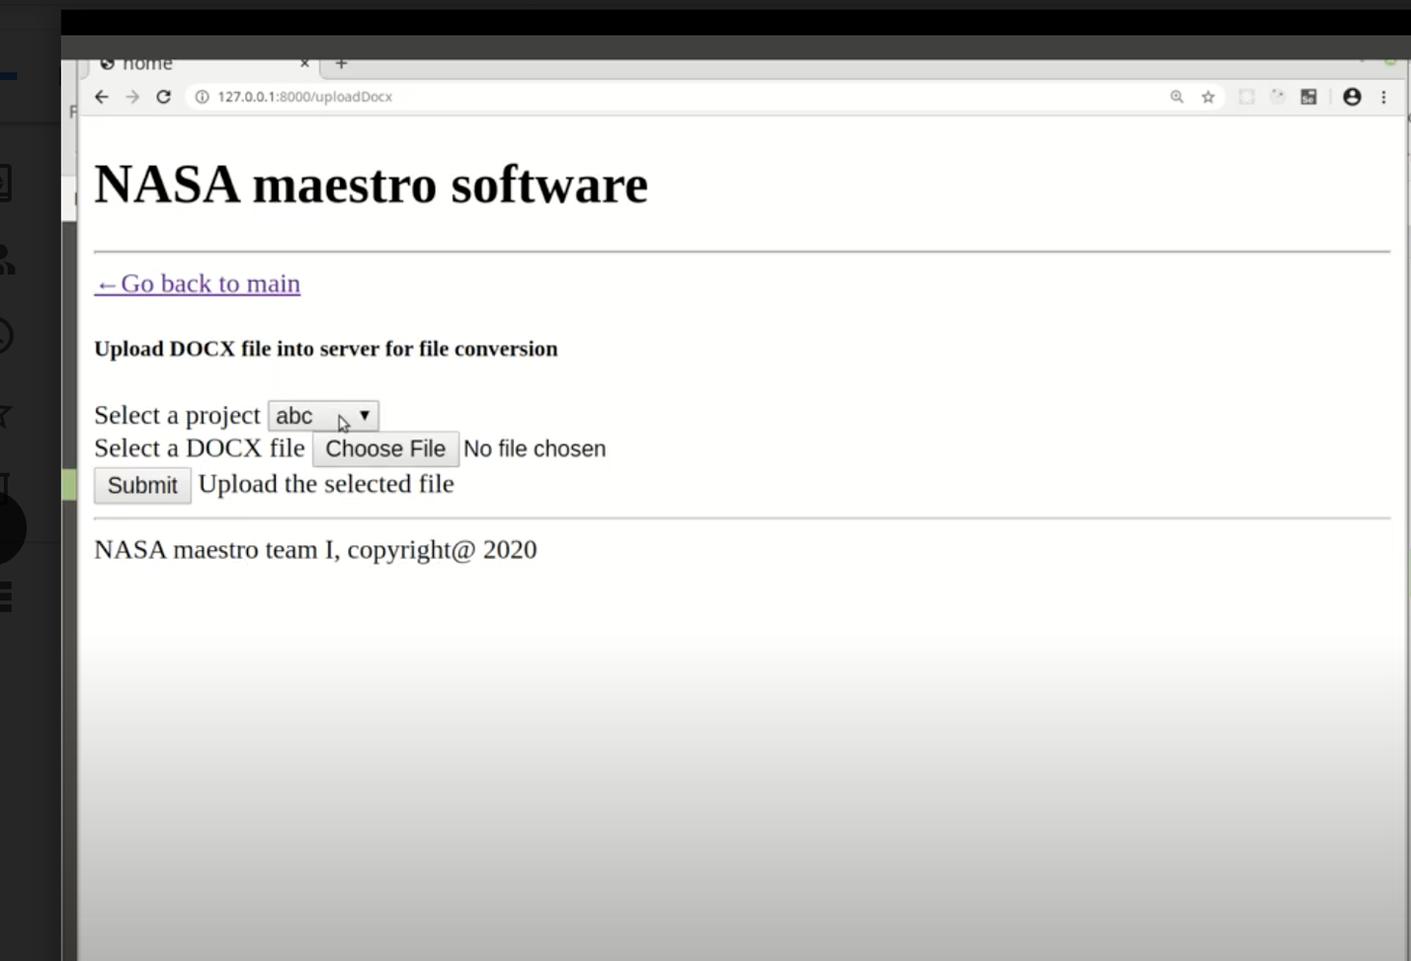

*Figure 2 – Upload a DOCX file*

## **Convert DOCX file to PDF file**

When ready to proceed to the next option, the user will be able to select the document to convert. “Select Upload DOCX file into server file” at which point the FTT will display the next sequential option in the procedure.

Navigation to the previous page to accomplish selecting another application file type.

After the final option is displayed, “After clicking Submit” will show the selected document within a few seconds after which the user will be able to review the selected option.

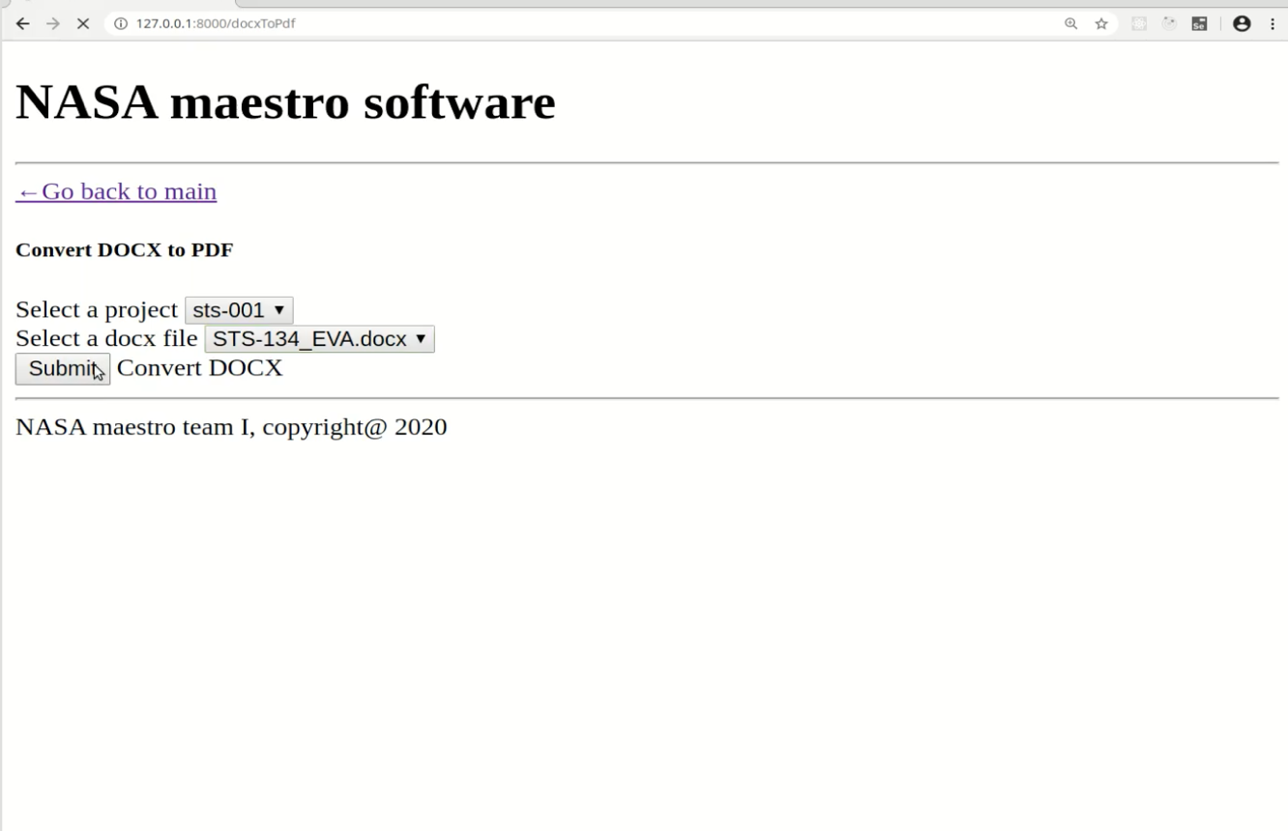

*Figure 3 – Convert DOCX file to PDF file*

## **Convert PDF document to PNG file**

Some steps have associated figures. In this case, the document selected will be displayed on the Maestro FTT. The user may navigate to any of the pages using the following option convert PDF to PNG file:

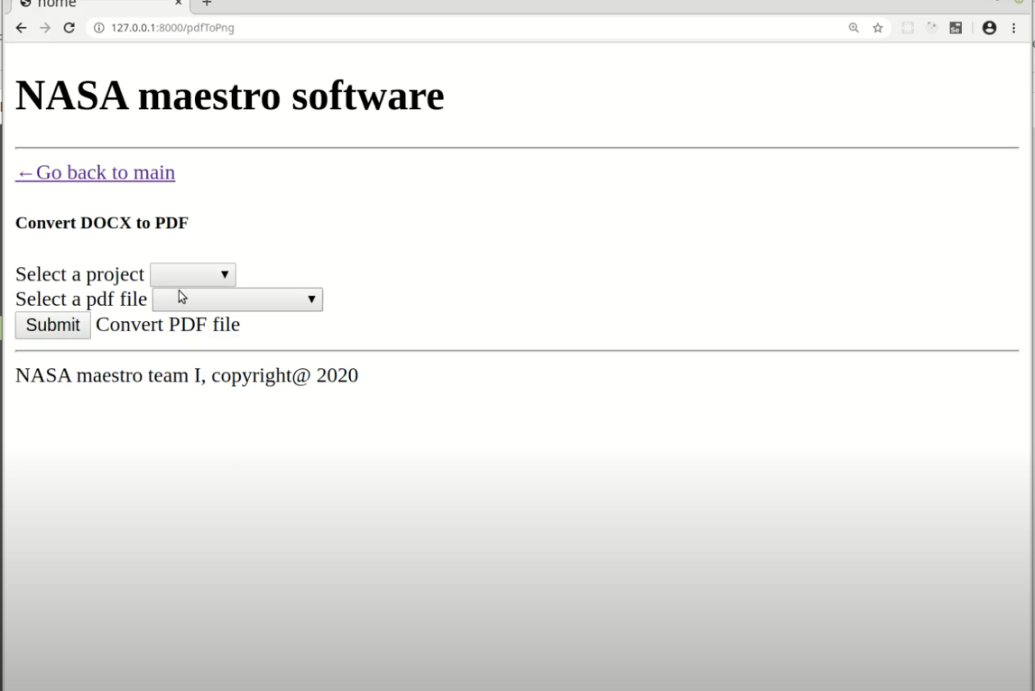

*Figure 4 – Convert PDF Document to PNG File*

## **Compare Images**

The user will choose to compare images. This step may also contain comparing two images not converting. The system displays a new file with both PNG files with a new name, which has the first image over the second image, saved as a PNG file.

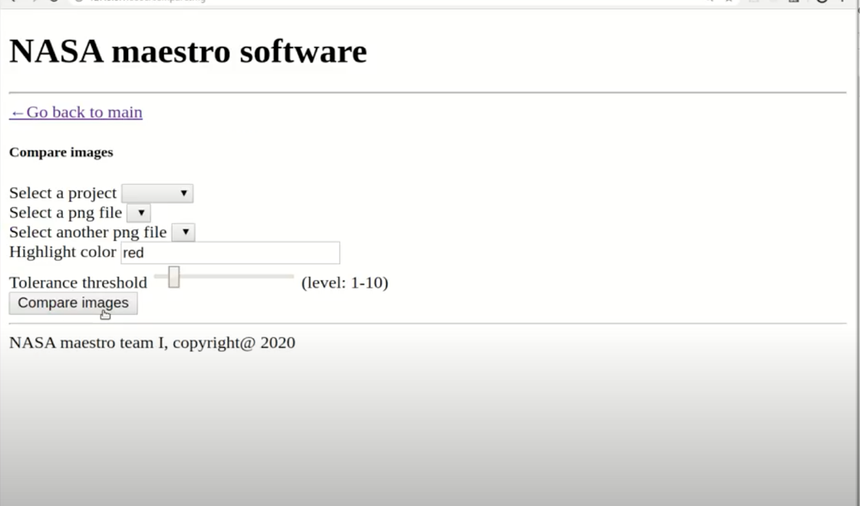

*Figure 5 – Compare Images display*

# **User Access Considerations**

All users of the NASA Maestro FTT system will have full access to the application.

# **Accessing the System**

The system may be accessed here: <https://appdev-nasa-maestro-verifier.herokuapp.com/home>

There is no login/password required.

# **Error Messages**

Should invalid input data be encountered when reading the procedure, the following errors may be encountered.

* Authorization
  + Authorization failed
    - Code 403
  + Request malformed
    - Code 400
  + Invalid or missing parameter
    - Code 422
  + Internal server error
    - Code 5xx
* Get Files
  + Authorization failed
    - Code 403
  + Request malformed
    - Code 400
  + Invalid or missing parameter
    - Code 422
  + Internal server error
    - Code 5xx
* Lint
  + Authorization failed
    - Code 403
  + Request malformed
    - Code 400
  + Invalid or missing parameter
    - Code 422
  + Internal server error
    - Code 5xx
  + File linting unsuccessful
    - Code 422
  + File not found
    - Code 404
* Get Roles
  + Authorization failed
    - Code 403
  + Request malformed
    - Code 400
  + Invalid or missing parameter
    - Code 422
  + Internal server error
    - Code 5xx
  + File not found
    - Code 404
* Get Tasks
  + Authorization failed
    - Code 403
  + Request malformed
    - Code 400
  + Invalid or missing parameter
    - Code 422
  + Internal server error
    - Code 5xx
  + File not found
    - Code 404
  + Role not found
    - Code 404

# **Special Considerations**

As mentioned in the Project Plan, there is a risk that the YAML file with the actual instructions may not be available to the front-end code by the end of the project. If this occurs, mockup data will be supplied to the front end for demonstration purposes.

# **Support**

NASA Team 1 will be available until April 26, 2020. At that point, the application and all associated documentation will be turned over to the stakeholders.

# **Supporting Information**

NA